**Django Checkpoint 2 - Dog Selector**

Build a web site that helps people to identify the best breed of dog for their lifestyles and preferences. The site should present a form that queries the user’s preferences on (at a minimum):

* Activity level
* Grooming requirements
* Intelligence
* Amount of shedding
* Coat length
* Size
* Behaviour with children
* Tendency to drool

The app doesn’t have to have a beautiful UI. For instance, the following is sufficient:

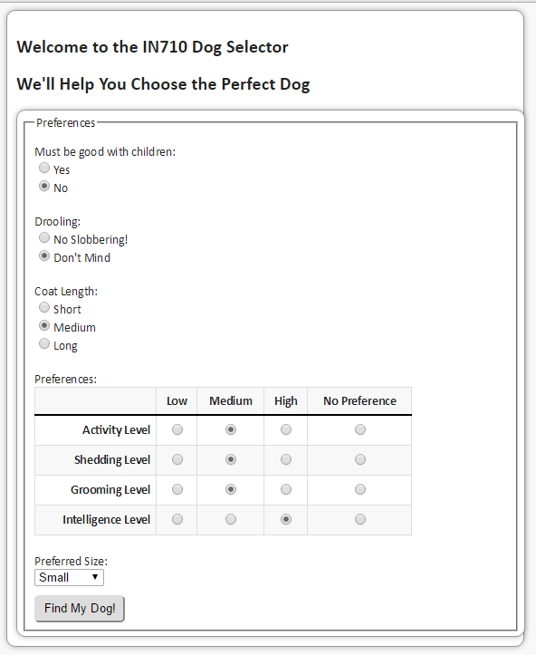

And the result can look like this:

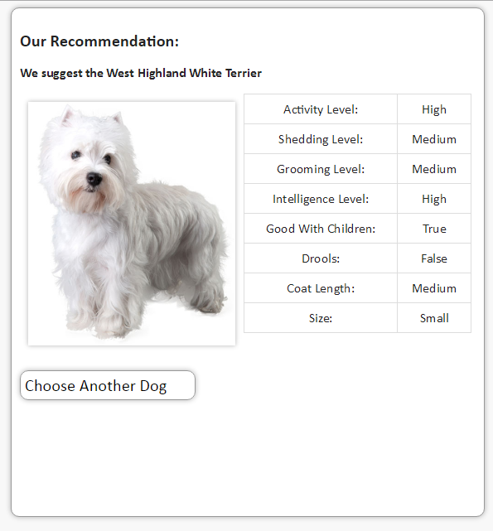

Don't forget that there may be no match for your dog preferences! (Find the next best and show them.) There can also be multiple matches - in that case I would like to see them all.